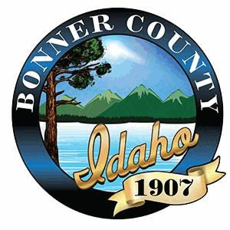

NOTICE OF PUBLIC HEARING

I hereby certify that a true and correct copy of this “Notice of Public Hearing” was digitally transmitted
or mailed (postage prepaid) on this 8th day of July 2025.
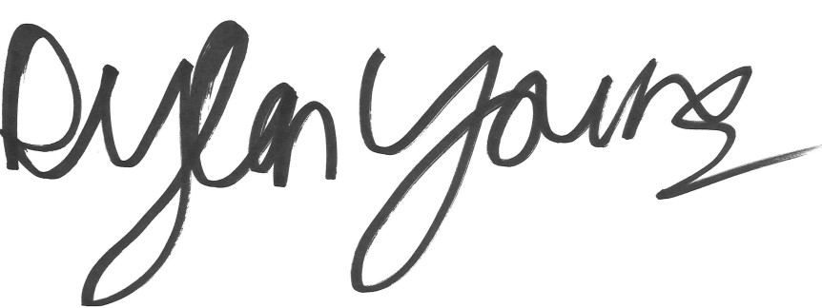

Dylan Young, Hearing Coordinator

This notice was mailed to political subdivisions, property owners within 300 feet of the subject property,
and the media on Tuesday, July 8, 2025.

NOTICE IS HEREBY GIVEN that the Bonner County Hearing Examiner will hold a public hearing at 1:30 pm on Wednesday, August 6, 2025, in the Bonner County Administration Building, 1500 Highway 2, Sandpoint, Idaho, by Zoom teleconference, and YouTube Livestream to consider the following request:

File V0019-25 - Variance - Street Setback

The applicants are requesting a 0-foot street setback, where 25 feet is required, to construct a new
accessory structure. The .990-Acres property is zoned Rural 10 (R-10). The project site is located off
Driftwood Shore in Section 17, Township 56 North, Range 1 East, Boise-Meridian. The project site is
located within the Sagle Fire District service area.

For details regarding this application, Zoom teleconference, or YouTube livestream, visit the Planning
Department web site at www.bonnercountyid.gov/departments/Planning. Staff reports are available
online or may be viewed at the planning department approximately a week before the scheduled
hearing.

Written statements must be submitted to the planning department record no later than seven
(7) days prior to the public hearing. Written statements not exceeding one standard letter sized,
single spaced page may be submitted at the public hearing. Statements can be sent to the Bonner
County Planning Department at 1500 Highway 2, Suite 208, Sandpoint, Idaho 83864; faxed to
866-537-4935 or e-mailed to planning@bonnercountyid.gov. The referenced start time stated above
reflects the beginning of the hearing. Specific file start time and hearing duration vary.

During the hearing for this application, the public will be given an opportunity to provide testimony
and/or evidence regarding how the proposal does or does not comply with the applicable approval
criteria of the Bonner County Revised Code. At the close of the public hearing, the governing body will
make a decision on the application that may include, but is not limited to, approval, denial, remand, or
continuance of the public hearing. Any person needing special accommodations to participate in the
public hearing should contact the Bonner County Planning Department at (208) 265-1458 at least 48
hours prior to the scheduled hearing.

If you have no comment or response, you may indicate below and return this form to the
Planning Department.

NO COMMENT_________________________________________ ___________
Name Date

