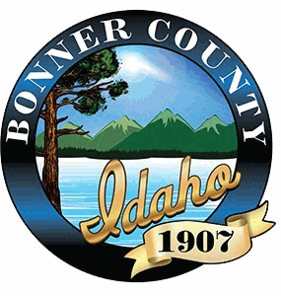
NOTICE OF PUBLIC HEARING

I hereby certify that a true and correct copy of this “Notice of Public Hearing” was digitally transmitted or mailed (postage prepaid) on this 1st day of July 2025.
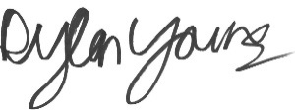
Dylan Young, Hearing Coordinator
This notice was mailed to political subdivisions, property owners within 300 feet of the subject property, and the media on Tuesday, July 1, 2025.

NOTICE IS HEREBY GIVEN that the Bonner County Commissioners will hold a public hearing at 1:30 pm on Thursday July 23, 2025 in the Bonner County Administration Building, 1500 Highway 2, Sandpoint, Idaho, by Zoom teleconference, and YouTube Livestream to consider the following request:
File VS0002-25 – Vacation Title 50 – Vacation of Private Easement
The applicant is requesting to vacate a portion of Burley Drive, a 40’ easement dedicated by the “Coyote Ridge” plat. The easement proposed to be vacated is approximately 0.57-acres. The project site is located off Peak View Drive in Section 34, Township 56 North Range 3 West, Boise-Meridian. The proposal is located within the service area of Selkirk Fire District.
For details regarding this application, Zoom teleconference, or YouTube livestream, visit the Planning Department web site at www.bonnercountyid.gov/departments/Planning. Staff reports are available online or may be viewed at the planning department approximately a week before the scheduled hearing.
Written statements must be submitted to the planning department record no later than seven (7) days prior to the public hearing. Written statements not exceeding one standard letter sized, single spaced page may be submitted at the public hearing. Statements can be sent to the Bonner County Planning Department at 1500 Highway 2, Suite 208, Sandpoint, Idaho 83864; faxed to 866-537-4935 or e-mailed to planning@bonnercountyid.gov. The referenced start time stated above reflects the beginning of the hearing. Specific file start time and hearing duration vary.
During the hearing for this application, the public will be given an opportunity to provide testimony and/or evidence regarding how the proposal does or does not comply with the applicable approval criteria of the Bonner County Revised Code. At the close of the public hearing, the governing body will make a decision on the application that may include, but is not limited to, approval, denial, remand, or continuance of the public hearing. Any person needing special accommodations to participate in the public hearing should contact the Bonner County Planning Department at (208) 265-1458 at least 48 hours prior to the scheduled hearing.

If you have no comment or response, you may indicate below and return this form to the Planning Department.

NO COMMENT
Name Date

